Education Scotland Event
Supporting Children & Young People of Armed Forces Families
Local authorities have a responsibility to comply with the Armed Forces Covenant Legislation, providing ‘due regard’ for the children and young people of armed forces families (Serving and Veteran) across education.
The Education Scotland Event (webinar) hosted in collaboration with the ADES National Education Officer, on Tuesday 24th October (16:00-17:00hrs) offers an opportunity for teachers and staff from schools and ELC settings to learn more about, and be introduced to, the lived-experience and educational journeys of armed forces families.
Conversations with professionals who have worked with these families will provide relevant knowledge, experience, and useful information.
Engagement in this event/webinar, and follow-up use of the Professional Learning Activity (NI Hub) and on Forces Children’s Education website, could help to establish a baseline of professional development, as outlined in the ADES Advice: Armed Forces Covenant Legislation document.
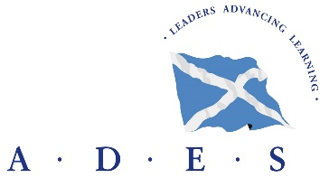

Carolyn MacLeod MBE
National Education Officer
for Children and Young People of Armed Forces families in Scottish Schools and ELC settings
ADES Association of Directors of Education in Scotland
nationaltransitionsofficerades@gmail.com |(m) 0793156596|www.forceschildrenseducation.org.uk

